FUNDAMENTAL OF PROGRAMMING

HOME TASK2  
SUBMITTED : SIR AFFAN

SUBMITTED BY ABDUL MANAN

QALAM 462449

TASK 1

#include <iostream>

using namespace std;

int main() {

int num;

cout<<"Please write a number here"<<endl;

cin>>num;

cout<<"YOUR GRADE IS"<<endl;

if (num>=90 && num<100) {// setting a range for which grades can be defined

cout<<"A"<<endl;

}

else if (num>=75&& num<90) {

cout<<"B"<<endl;

}

else if (num>=60 && num<75) {

cout<<"C"<<endl;

}

else if (num>=45 && num<60) {

cout<<"D"<<endl;

}

else if (num>=0 && num<45) {

cout<<"F"<<endl;

}

return 0;

}

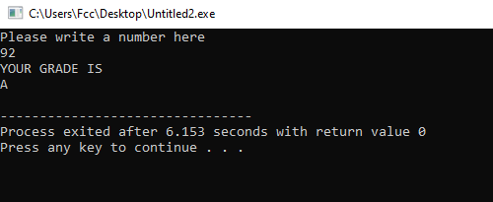

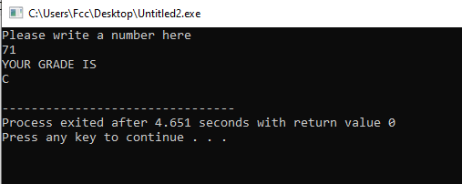

TASK 2

#include <iostream>

using namespace std;

int main() {

int num;

cout<<"Please write a number here"<<endl;

cin>>num;

if (num%5==0 && num%2==0) { // the number is divisble by 5 and divisble by 2 hence even

cout<<"the number is divisible by 5 and even"<<endl;

}

else if (num%5==0 ) {

cout<<"the number is divisible by 5 but odd"<<endl;

}

else if (num%2==0) {

cout<<"the number is even but not divisible by 5"<<endl;

}

else {

cout<<"the number is odd and not divisible by 5"<<endl;

}

return 0;

}

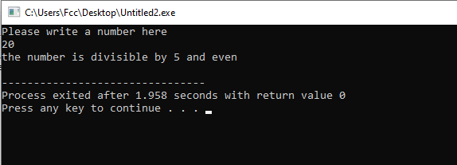

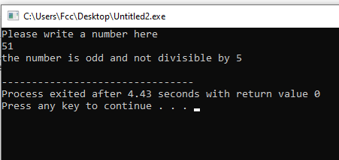

TASK3

#include <iostream>

using namespace std;

int main() {

int year;

cout<<"Enter a year"<<endl;

cin>>year;

if (year%400==0 || (year%4==0 && year%100!=0)) { // the year is divisble by 400. or it is divisble by 4 and not divisible by 100

cout<<"The Year "<< year <<" is a leap year" <<endl;

}

else {

cout<<"The Year "<< year <<" is not a leap year"<<endl;

}

return 0;

}

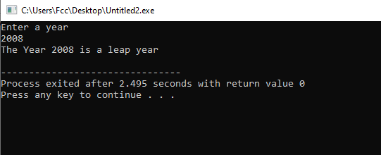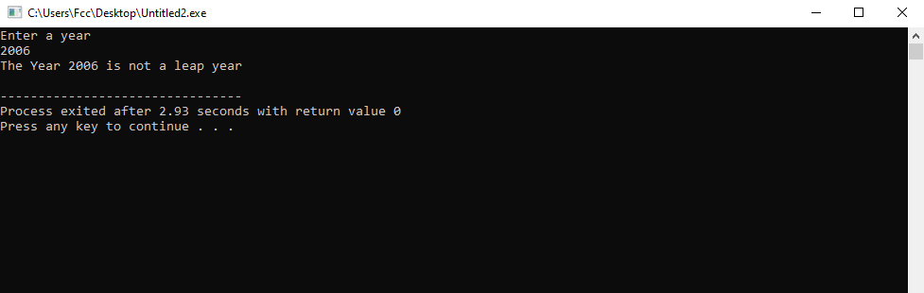

TASK4

#include <iostream>

using namespace std;

int main() {

float gpa,att;

cout<<"Please write your gpa and attendance"<<endl;

cin>>gpa>>att;

if (gpa>=3.5 && att>=80) { // Setting a condition that if gpa and attendace is above 3.5 and 80% than eligible for scholarship

cout<<"you are eligible for scholarship"<<endl;

}

else {

cout<<"you are not eligible for scholarship"<<endl;;

}

return 0;

}

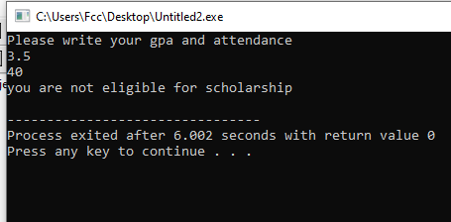

TASK 5

#include<iostream>

using namespace std;

int main () {

char alphabet;

cout<<"Please write an alphabet "<<endl;

cin>> alphabet;

if (alphabet== 'a' || alphabet== 'e' || alphabet=='i' || alphabet=='o' || alphabet=='u' ) {

cout<<"the character is a vowel "<<endl;

}

else {

cout<<"the character is consonant";

}

Return 0;

}

